**Database Management Task**

Creating the database of name heal_bharat

-: **Create database heal_bharat;**

By using the database heal_bharat

-:**use heal_bharat;**

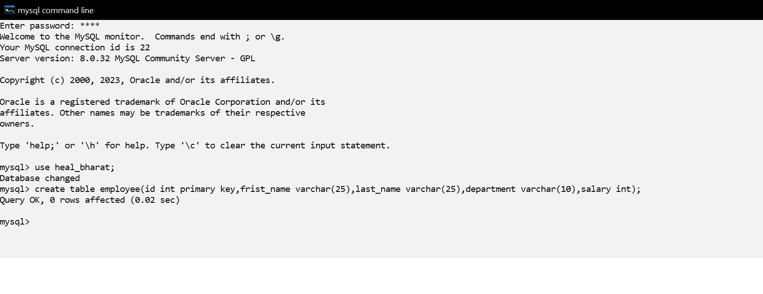Creating a table employee into database heal_bharat

-: **create table employee (id int primary key, frist_name varchar(25), last_name varchar(25),department varchar(10),salary int);**

Inserting the data into the table employee

**-: insert into table employee values(1,”John”,”Doe”,”HR”,45000);**

**-: insert into table employee values(2,”Jane”,”Smith”,”IT”,75000);**

**-: insert into table employee values(3,”Mike”,”Johnson”,”Finance”,85000);**

**-: insert into table employee values(4,”Emily”,Davis”,”IT”,60000);**

**-: insert into table employee values(5,”Sarah”,”Wilson”,”Marketing”,50000);**

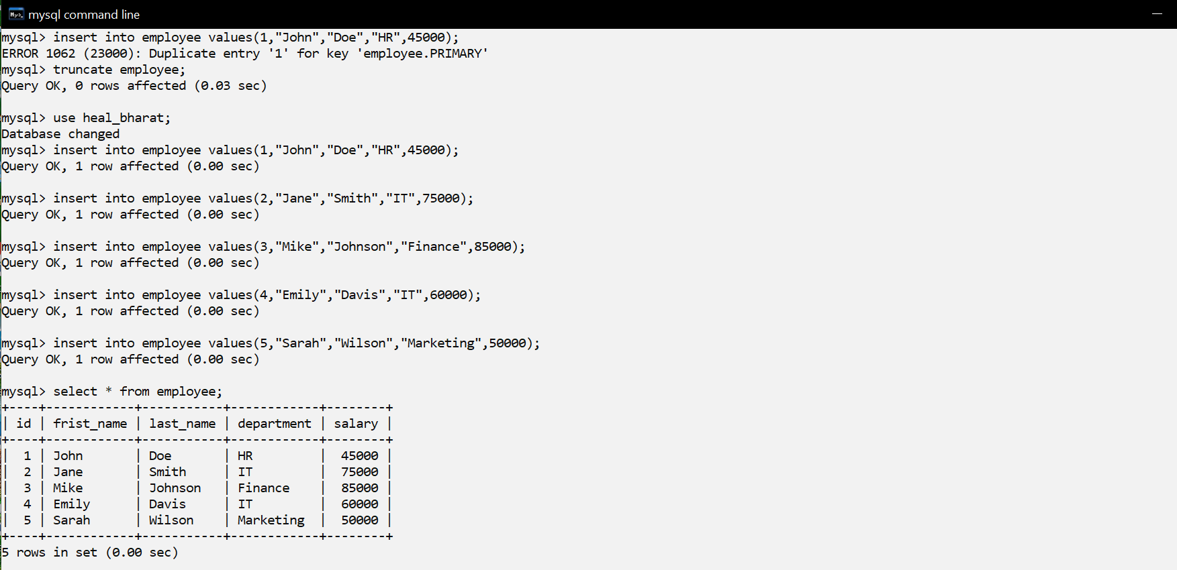

Query to retrieve the names and departments of all employees who earn more than 50000

-: **select concat(frist_name,” ”,last_name) as name , department from employee where salary > 50000;**

